Student Internship Guide

This guide aims to outline the roles and responsibilities of the Student Intern.

1. AIMS OF THE INTERNSHIP PROGRAMME

The aims of the Internship Programme (ITP) are to:

1. Put into practice the knowledge and skills acquired by the student with regards to understanding and applying concepts and methodologies in systems analysis and system designs, coding and testing programs, infrastructure provisioning and support;
2. Further develop the student’s interpersonal and collaborative skills through working in teams;
3. Provide opportunities for the student to communicate with users and other IT professionals;
4. Boost the student’s competency, in understanding business processes and implementing usable applications based on existing or new technologies; this includes, but not limited to, mobile computing applications, web-based development, enterprise system development, end user computing development, cyber security and forensics evaluation, data analytics and visualization;
5. Prepare the student for ready absorption into the workforce so that he/she can contribute effectively to the digital economy upon graduation;
6. Help forge and support a closer relationship between the industry and Nanyang Polytechnic.
7. LEARNING OUTCOMES

The Internship is aimed at providing a real-life work environment and facilitating a structured and integrated learning programme for students.

On successful completion of their internship, students will be able to:

1. Demonstrate the application of knowledge and skill sets acquired from the course of study and workplace in the assigned job function(s)
2. Solve workplace challenges by analysing the work environment and conditions, and using appropriate skill sets acquired from course of study
3. Articulate career options by considering opportunities in the company, sector, and industry for professional and educational advancement
4. Communicate and collaborate effectively and appropriately with different professionals in the work environment through written and oral means
5. Exhibit critical thinking and problem-solving skills by analysing underlying issue(s) to

challenges

1. Demonstrate the ability to harness resources by analysing challenges and considering

opportunities

1. Recommend ideas to improve work effectiveness and efficiency by analysing

challenges and considering viable options

1. Demonstrate appreciation and respect for diverse groups of professionals by engaging

harmoniously with different company stakeholders (e.g. colleagues, supervisors,

suppliers etc.)

1. Exhibit professional ethics at work
2. INTERNSHIP EVALUATION CRITERIA

The organisation will evaluate the student based on the following criteria:

1. Work Ethics & Professionalism – ability to demonstrates a professional, cooperative, and respectful attitude toward others in the workplace
2. Professional Efficiency – effectiveness in applying technical skills to the task assigned
3. Quality of Work/ Work Outcomes – ability to produce quality work and contribute to the task assigned
4. Communication & Teamwork – effectiveness in communicating and working with others towards accomplishment of common goals
5. Independent Learning Skills – effectiveness in completing assigned tasks independently

Refer to Annex 1 for detailed ITP assessment rubrics.

1. INSURANCE
2. Students on the Internship are covered by Nanyang Polytechnic’s Group Personal Accident Insurance Policy.
3. Students on the Overseas Internship are responsible to purchase adequate overseas travel insurance on their own arrangement.
4. In case of accidents/serious illness, the student must inform the IIM of the organisation and the SIM appointed by the School immediately or as soon as possible.
5. Students wishing to take additional cover should make their own arrangements.
6. STUDENT DISCIPLINE

The following is a list, though not exhaustive, of the types of misconduct which will lead to disciplinary action:

1. Absence without official leave or permission;

1. Misconduct in the course of the Internship such as use of bad or foul language, offensive behaviour, insubordination, refusal to obey instructions, failure to comply with organisation’s safety rules or other procedures;
2. Late for work;
3. Carelessly or negligently damaging property of the organisation that the student is attached to;
4. Stealing, gambling or fighting;
5. Failure to report to the assigned organisation on the date of commencement of the Internship;
6. Any other reasons sufficiently serious to justify disciplinary action.
7. STUDENT ATTENDANCE

The student is required to:

1. Inform the IIM and the SIM of his/her absence on medical grounds (if any) immediately;
2. Submit original medical certificates or any documentary proofs of absence, if any, to the company with the endorsement of the IIM;
3. Update the absence from work due to medical grounds in the e-Log;
4. As this is an internship programme, students are not entitled to any annual leave.
5. INTERNSHIP DOCUMENTS
6. During the internship, the student is required to submit e-Logs via the ITP system. The e-Log is meant to record the accomplishments of the student in the internship and it will be used by SIM and IIM for monitoring and grading purposes. Note the following guidelines:
   * The student needs to fill in two sections, namely, the weekly summary and the weekly reflection sections.

* The weekly summary section briefly describes the daily work activities done in the company. This will be read and graded by the IIM regularly.
* The weekly reflection should be written in accordance to the guidelines in Annex 2. This section will be read by the IIM regularly.
* The SIM will also read and comment on the e-Log and the reflections regularly.

1. At the end of the internship, the student is required to submit the following documents.

**Student Performance Grading Form**

* Student must print out Annex 5, the student performance grading form, and ask the IIM to grade and sign the form. Note: this is a closed assessment and the form must be sealed by the IIM.

**ITP Report & Poster**

1. Report and Poster writing should be based on guidelines given. Refer to Templates for ITP Poster and Report Writing in Annex 3 and Annex 4. The students are reminded to complete the report for submission and grading by the SIM.
2. The documents should be vetted by the IIM before submission, to ensure confidential information of the organisation will not be accidentally divulged.
3. Students should ensure the Student Performance Grading Form is graded and signed before submission to SIM.
4. The documents must be submitted to the SIM upon completion of the internship.
5. Students are advised to document and draft their report as they progress through the internship. They should avoid procrastination.
6. Students will also be evaluated based on the documents submitted and the assessment made by the IIM and the SIM assigned by the school.
7. IMPORTANT DATES

|  |  |
| --- | --- |
| **IP Week #** | **Activity Description** |
| (Prior to IP commencement) | **Attend ITP Student Briefing & meet SIM** |
| Week 1 | **Report to Company**  **Write Weekly Log and Reflection**  (1st company visit by SIM) |
| Week 2-5 | **Write Weekly Log and Reflection** |
| Week 6 | **(2nd company visit by SIM)**  **Write Weekly Log and Reflection** |
| Week7-10 | **Write Weekly Log an Reflection**  **Prepare to write report and poster** |
| Week 11 | **Submit Poster, Report with Overall report grading form and Student Performance Grading form to IIM to vet and sign**  **Write Weekly Log and Reflection** |
| Week 12 | **(3rd visit & assessment by SIM/IIM)**  **Write Weekly Log and Reflection** |

1. MODULE DETAILS

|  |  |  |
| --- | --- | --- |
| Duration | 12 Weeks | 24 Weeks |
| Periods for Internship | P1: Mar – May  P2: Jun – Aug  P3: Sep – Nov  P4: Nov – Feb | P1: Mar – Aug  P2: Sep – Feb |
| Credits | 12 | 24 |
| People Involved | Student Intern  SIM: School Internship Mentor  IIM: Industry Internship Mentor  ITPC: Internship Programme Co-ordinator | |

**Annex 1: ITP Assessment Rubrics**

The assessment rubrics for these criteria are defined as follow:

**IIM Assessment Rubrics - Workplace (40%)**

|  |  |  |  |  |  |
| --- | --- | --- | --- | --- | --- |
| **Assessment Criteria** | **Performance Level Definitions** | | | | |
| **Very Good** | **Good** | **Satisfactory** | **Below Average** | **Poor** |
| **Work Ethics & Professionalism** | Displays strong commitment to the job always | Displays commitment to the job most of the time | Displays moderate commitment to the job most of the time | Displays commitment to the job occasionally | Displays little or no commitment to the job |
| Completes tasks ahead of time | Completes tasks on time | Completes tasks on time mostly; a few instances of missing deadlines by a day or two | Needs prompting to complete tasks on time | Puts in little effort to complete tasks |
| Is respectful when interacting with co-workers and clients always | Is respectful when interacting with co-workers and clients most of the time | Is respectful when interacting with co-workers and clients most of the time | Is respectful when interacting with co-workers and clients some of the time | Is respectful when interacting with co-workers and clients occasionally |
| Always (> 90%) punctual for work and meetings, exceptions with valid reasons approved by supervisor* | Mostly (> 80%) punctual for work and meetings, exceptions with valid reasons approved by supervisor* | Mostly (> 80%) punctual for work and meetings, with several cases of late without valid or approved reason | Late for work or meetings some of the time (<25%), shows improvement after counselling by supervisor* | Often (>75% of the time) late for work or meetings, even after counselling by supervisor* |
| **Professional Proficiency** | Possesses very good professional/ technical knowledge for the tasks assigned | Possesses s good professional/technical knowledge for the tasks assigned | Possesses just enough professional/ technical knowledge and skills for the tasks assigned | Possesses limited professional/ technical knowledge & skills for the tasks assigned | Possesses poor or no professional/technical knowledge & skills and unable to complete tasks assigned |

|  |  |  |  |  |  |
| --- | --- | --- | --- | --- | --- |
| **Assessment Criteria** | **Performance Level Definitions** | | | | |
| **Very Good** | **Good** | **Satisfactory** | **Below Average** | **Poor** |
| **Professional Proficiency** | Delivers thorough, accurate and timely work always | Delivers thorough, accurate and timely work most of the time, with minor rework needed in a few instances | Delivers work with a few instances of shortcomings in thoroughness, accuracy or timeliness | Delivers work with regular instances of shortcomings in thoroughness, accuracy or timeliness | Prone to mistakes or lateness in work output and needs very close guidance |
| Work outcomes always exceed stakeholders’ expectations | Work outcomes meet stakeholders’ expectations most of the time | Work outcomes meet stakeholders’ expectations most of the time with some guidance | Work outcomes barely meet stakeholders’ expectations most of the time even with close guidance | Work outcomes far below stakeholders’ expectations most of the time |
| **Communication & Teamwork** | Able to speak & write with clarity & appropriateness always | Able to speak & write with clarity & appropriateness most of the time | Requires some guidance to speak & write with clarity & appropriateness | Requires constant guidance to speak & write with clarity & appropriateness | Unable to communicate clearly or appropriately in speech and writing most of the time even with guidance |
| Able to embrace diversity at work always | Able to embrace diversity at work most of the time | Able to embrace diversity at work most of the time, with some issues | Able to embrace diversity at work with some help from supervisor | Unable to embrace diversity at work. |
| Able to work well with others to achieve common goals always | Able to work well with others to achieve common goals most of the time | Able to work with others to achieve common goals with occasional guidance | Has some difficulties working with others occasionally | Has difficulties working with others frequently even with guidance |
| **Independent Learning Skills** | Always able to identify gaps in own knowledge/ skills and able to close those gaps, primarily through self-learning, and then coaching from others | Able to identify gaps in own knowledge/skills and able to close those gaps, primarily through self-learning, and then coaching from others, most of the time | Able to identify some gaps in own knowledge/skills and able to close those gaps, primarily through coaching from others, with some self-learning | Able to identify some gaps in own knowledge/skills and mostly rely on seeking coaching/help from others to close those gaps | Unable to identify gaps in own knowledge/skills and does not respond to coaching/help from others to close those gaps |

**SIM Assessment Rubrics (60%)**

**Work Log**

|  |  |  |  |  |  |
| --- | --- | --- | --- | --- | --- |
| **Assessment Criteria** | **Performance Level Definitions** | | | | |
| **Very Good** | **Good** | **Satisfactory** | **Below Average** | **Poor** |
| **Content** | Weekly records of work done & objectives achieved are complete and concise always | Weekly records of work done & objectives achieved are complete and concise most of the time | Weekly records of work done & objectives achieved are complete and concise half the time | Weekly records of work done & objectives achieved are in-complete most of the time | Weekly records of work done & objectives achieved are complete and concise always |
| **Timeliness** | Work Log is submitted by the due date all the time | Work Log is submitted by the due date most of the time with prior approval from the SIM for late submissions | Work Log is submitted within 3 working days after due date most of the time with prior approval from the SIM for late submissions | Work Log is submitted within 3 working days after due date most of the time without prior approval from the SIM for late submissions | Work Log is submitted by the due date all the time |

**Reflections**

|  |  |  |  |  |  |
| --- | --- | --- | --- | --- | --- |
| **Assessment Criteria** | **Performance Level Definitions** | | | | |
| **Very Good** | **Good** | **Satisfactory** | **Below Average** | **Poor** |
| **Reflection skills** | Reflection covers many learning points at work and always connects with insights on individual’s strengths, interests, values, personality, skills and weaknesses, with action item(s) for self-improvement always | Reflection covers many learning points at work and most of the time connects with insights on individual’s strengths, interests, values, personality, skills and weaknesses, with action item(s) for self-improvement most of the time | Reflection covers 1 or 2 learning points at work and sometimes connects with insights on individual’s strengths, interests, values, personality, skills and weaknesses, with action item(s) for self-improvement sometimes | Reflection is superficial, with mere descriptions of work situations and little effort to elaborate on learning points | Reflection covers many learning points at work and always connects with insights on individual’s strengths, interests, values, personality, skills and weaknesses, with action item(s) for self-improvement always |
| **Quality of writing** | Writing is coherent, with minimal errors in grammar, spelling and punctuation. No copying or plagiarism found | Writing is coherent and has minor errors in grammar, spelling and punctuation. No copying or plagiarism found | Writing is largely coherent and has some errors in grammar, spelling and punctuation. No copying or plagiarism found | Writing is somewhat coherent and has major errors in grammar, spelling and punctuation. Substantial copying or plagiarism found | Writing is coherent, with minimal errors in grammar, spelling and punctuation. No copying or plagiarism found |

**Report**

|  |  |  |  |  |  |
| --- | --- | --- | --- | --- | --- |
| **Assessment Criteria** | **Performance Level Definitions** | | | | |
| **Very Good** | **Good** | **Satisfactory** | **Below Average** | **Poor** |
| **Organisation** | Information is presented in a clear and logical order with all essential deliverables present. Paragraphs and transitions enhance readability and comprehension. | Information is presented in a clear and logical order with most essential deliverables present. Paragraphs and transitions support readability and comprehension. | Information presented in a clear and logical order in most of the report, with most of the essential deliverables present. | The report is poorly organised in a few parts, with somewhat abrupt transitions in content. Needs extra effort to read for understanding. | Report is very poorly organised; no logical progression; confusing to read and difficult to understand. |
| **Content** | Appropriately present relevant professional/ technical content in the whole report | Appropriately present relevant professional/ technical content in most of the report | Professional/ technical content is presented but some of it are not so appropriate or relevant | Professional/ technical content is presented but most of it are not appropriate or relevant | Little to no relevant professional/ technical content in the report |
| **Quality of Writing** | Report is well formatted with minimal errors in grammar, spelling and punctuation | Report has minor formatting, grammar, spelling and punctuation errors | Report has some formatting, grammar, spelling and punctuation errors | Report has some formatting errors. Contains major grammar, spelling and punctuation errors | Report is not formatted and contains major grammar, spelling and punctuation errors |
| **Analysis of Assignments / Recommendations for Improvements/ Insights on Educational & Career Guidance** | Analysis of work achieved is thoughtful and coherent; covers possible improvements and new skills/knowledge learnt, and includes deep insights gathered to guide future educational & career choices | Analysis of work achieved is thoughtful; covers possible improvements and new skills / knowledge learnt, and includes ideas gathered to guide future educational & career choices | Analysis of work achieved is simple and includes new skills / knowledge learnt, with brief mention of future educational & career choices | Analysis of work achieved is simple. Did not include possible improvements and new skill / knowledge learnt, nor insights on future educational & career choices | No analysis of what has been achieved and what new skills / knowledge has been learnt, nor future educational and career choices |

**Presentation**

|  |  |  |  |  |  |
| --- | --- | --- | --- | --- | --- |
| **Assessment Criteria** | **Performance Level Definitions** | | | | |
| **Very Good** | **Good** | **Satisfactory** | **Below Average** | **Poor** |
| **Presentation Skills** | Engages with the audience through use of appropriate body language and seamless flow of delivery throughout. Able to highlight impact of own work succinctly always | Engages with the audience through use of appropriate body language and delivery most of the time, no glaring errors that distract the audience. Able to explain impact of own work most of the time. | Engages with the audience through use of appropriate body language and delivery most of the time, but some glaring errors exist that distract the audience. Able to describe some impact of own work some of the time. | Delivers the presentation mechanically. Unaware of inappropriate body language at times. Able to list own work outcomes but fail to explain their impact. | Very poor eye contact, body language and voice projection. Presenter’s appearance or gestures disengages the audience from the presentation. Unable to explain impact of own work. |
| **Ability to Answer Questions** | Able to answer all questions with clarity and provide very good insights to the audience | Able to answer all questions with clarity and provide good insights to the audience | Able to answer all questions with some clarity and provide some insights to the audience | Able to answer all questions. However, quality of answers is just satisfactory | Able to answer a few questions. However, quality of answers is poor |

**Annex 2: How to Write a Reflection**

**How to write a reflection**

**What is Reflection?**

Reflection or reflective writing enables the documentation of experiences, thoughts, ideas and conclusions that signpost the your learning journey. It is evidence of looking back at an event, an idea, an experience and a process that involves the following:

* analysing and commenting on the event from your own experience
* exploring and explaining the importance or relevance of the event
* explicitly saying what you have learned or concluded from the experience

**Structure of a reflection / reflective writing**

* ***Description***
* What is it? What happened? Why am I talking about it?
* ***Interpretation***
* What is significant / important, relevant, interesting, useful, desirable, feasible, related?
* ***Outcome***
* What have I learn from this? How will it influence my future work?

- **End** -

**Annex 3: Templates for ITP Poster**

**Templates for ITP Poster**

• The purpose is to showcase your attachment experiment.

• Information on:

* + Company
  + Project
  + Lesson learnt
  + Yourself
* Some samples for your reference

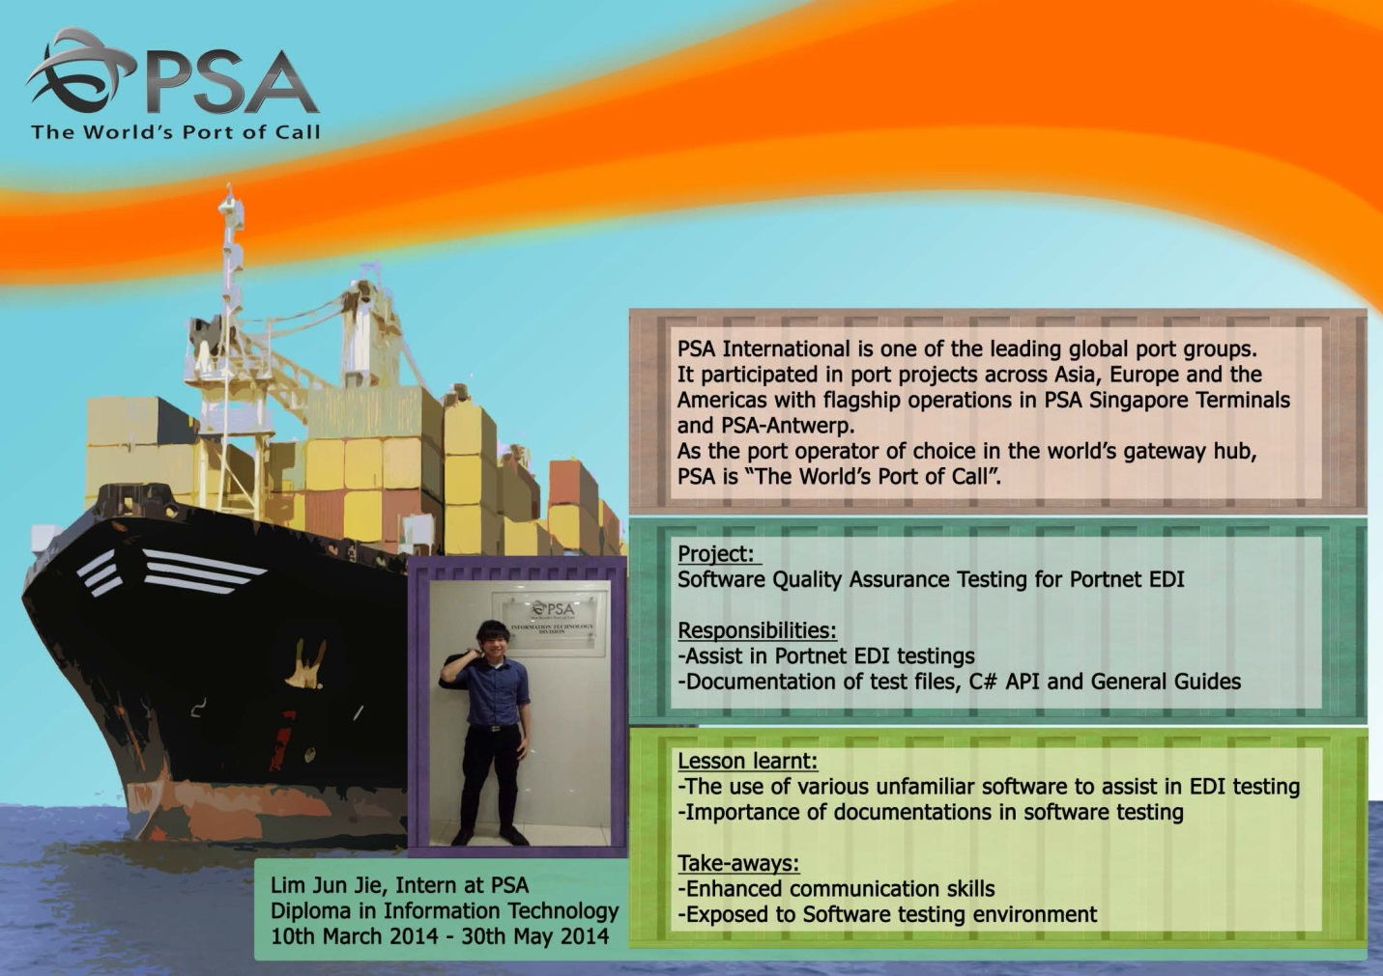

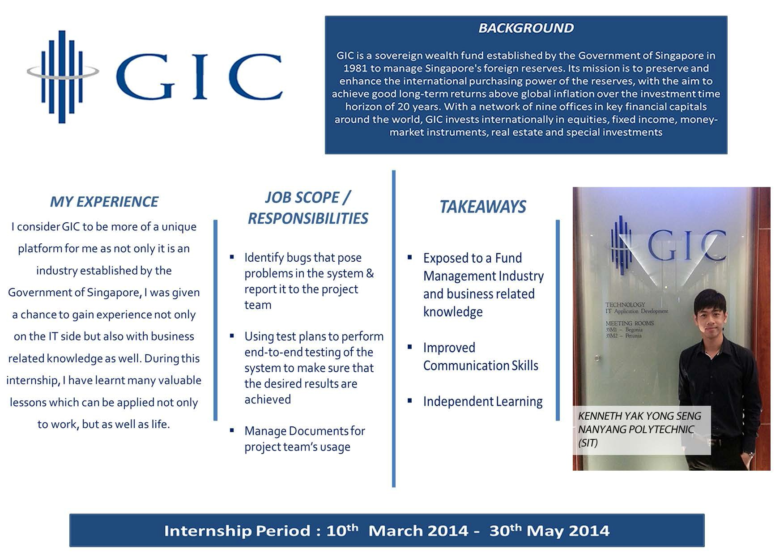

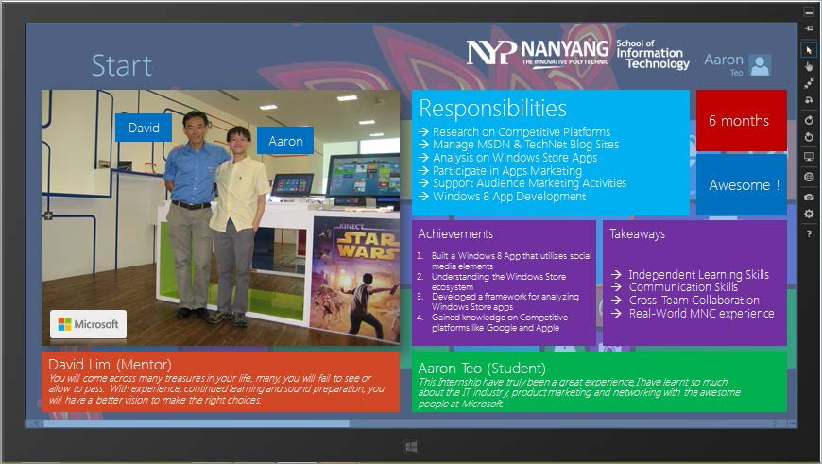

**Annex 4: Templates for ITP Report Writing**

# Templates for ITP Student Report Writing

The ITP Student Report should have the following:

(I) Content Requirement

1. **Cover Page**. All the items specified must be included. However, you may deviate from the format given. For example, you may prefer center justification instead of right justification.
2. **Acknowledgement Page**
3. **Table of Contents Page**
4. **Sections 1.0 - 6.0** and their respective subsections if any. You should not omit any section from 1.0 to 5.0. If there is no project enhancement, section 6.0 may be omitted.
5. **Appendices** if any

(II) Typographical Requirement (must be followed strictly)

Paper Size : A4

Fonts : Arial

Font Size : minimum 12.0 pt

Margins per Page : 1 inch from, bottom, left, right

Pagination : bottom, center for section 1.0 to 6.0

Line spacing : 1.5 lines

Tab Spacing : every 0.5 inch

Sentence Spacing : 2 spaces before the start of a new sentence

<< project title; right justified, cap, bold>>

<< project title next line, if any; right justified, cap, bold >>

<< project title third line, if any; right justified, cap, bold >>

INTERNSHIP

REPORT

<< student name, right justified, cap >>

<< admission number, right justified, cap >>

<<IT3579/IT3699/IT3339/IT3539/IT3769/IT3639/IT3299>> INTERNSHIP PROGRAMME

AY 2019/2020 (Period <<number 1,2,3 or 4>>)

DIPLOMA IN <<Full Course Name>>

SCHOOL OF INFORMATION TECHNOLOGY

NANYANG POLYTECHNIC

ACKNOWLEDGEMENTS {5th line}

<< name1 >> <<details of the acknowledgment>> {8th line}

<< name2 >> <<details of the acknowledgment>> {10th line}

<< name3 >> <<details of the acknowledgment>> {12th line}

<< name4 >> <<details of the acknowledgment>> {14th line}

TABLE OF CONTENTS {5th line}

SECTIONS {8th line}

1.0 ORGANISATION BACKGROUND {11th line}

1.1 << subsection’s title, if any >>

1.2 << subsection’s title, if any >>

{1 line spacing}

2.0 ATTACHMENT BACKGROUND

2.1 << subsection’s title, if any >>

{1 line spacing}

3.0 PROJECT BACKGROUND

3.1 << subsection’s title, if any >>

{1 line spacing}

4.0 PROJECT SCHEDULE

4.1 << subsection’s title, if any >>

{1 line spacing}

5.0 PROJECT ACCOMPLISHMENTS

5.1 << subsection’s title, if any >>

{1 line spacing}

6.0 ANALYSIS OF ASSIGNMENT/RECOMMENDATIONS FOR IMPROVEMENT

6.1 << subsection’s title, if any >>

APPENDICES {after 3 lines spacing}

{1 line spacing}

Appendix 1 << appendix 1’s title, if any >>

Appendix 2 << appendix 2’s title, if any >>

1.0 ORGANISATION BACKGROUND

This section should describe about the organisation where you were attached.

* Name, address and country of the organisation
* Nature of the business
* Organisation chart
* Platform and Technology used (Hardware and Software)

2.0 ATTACHMENT BACKGROUND

This section describes the background of your attachment to the organisation.

* Description of the department and/or section you were attached to
* Role of your department
* Organisation chart of your department and/or section
* Period of Attachment
* Name and designation of the industry internship mentor (IIM)
* Name and designation of the school internship mentor (SIM)
* Your role during the attachment

3.0 PROJECT BACKGROUND

This section describes the project you were assigned.

* Project Name
* Project Background / History
* Project Scope
* Project Description (include hardware and software tools that you used)

4.0 PROJECT SCHEDULE

This section should have a GANTT chart describing the various project tasks assigned to you.

* Project main tasks and their subtasks
* Expected man-effort and time frame for each task
* Actual man-effort and time frame for each task

5.0 PROJECT ACCOMPLISHMENTS

This section describes the work you have done, your contributions made and the experience gained during your attachment.

* For each project task:
* describe the work done to accomplish your task
* list out the deliverables made and briefly describe each deliverable
* mention any major problems faced and describe how they were resolved
* describe the experience gained or any lesson that you have learnt

6.0 ANALYSIS OF ASSIGNMENT/RECOMMENDATIONS FOR IMPROVEMENT

This section describes what has been achieved and what new skills / knowledge has been learnt.

Describe any insights gain/gathered which can provide a guide to future education/ career choices.

**END**

ANNEX 5: Student Performance Grading Form

COMPANY’S EVALUATION OF STUDENT’S PERFORMANCE

Name of Company/Organisation: ______________________________________________________

Name of Student: __________________________________________________________________

Please evaluate the student’s performance on the basis of the following criteria:

|  |  |  |
| --- | --- | --- |
| (1) | **WORK ETHICS & PROFESSIONALISM**  (ability to demonstrates a professional, cooperative, and respectful attitude toward others in the workplace) | _____ / 10 |
| (2) | **PROFESSIONAL EFFICIENCY**  (effectiveness in applying technical skills to the task assigned) | _____ / 10 |
| (3) | **QUALITY OF WORK/ WORK OUTCOMES**  (ability to produce quality work and contribute to the task assigned) | _____ / 10 |
| (4) | **COMMUNICATION & TEAMWORK**  (effectiveness in communicating and working with others towards accomplishment of common goals) | _____ / 10 |
| (5) | **INDEPENDENT LEARNING SKILLS**  (effectiveness in completing assigned tasks independently) | _____ / 10 |

**_________________________________________________________________________________**

|  |  |
| --- | --- |
| **Overall Performance** | _____ / 10 |

Additional Comments, if any:

**_________________________________________________________________________________**

**_________________________________________________________________________________**

**_________________________________________________________________________________**

**_________________________________________________________________________________**

_________________________________________ ____________________

Name and Signature of Industry Internship Mentor Date